LABORATORIYA ISHI №4
Mavzu: PHP orqali MySQL ma’lumotlar bazasiga ulanish

1. Ishning maqsadi
- Tayyor MySQL bazaga PHP orqali ulanish
- SELECT so‘rovlarini bajarish
- INNER JOIN orqali bir nechta jadval ma’lumotlarini chiqarish
- MySQLi (procedural, OOP) va PDO usullarini taqqoslash
- Ular orasidagi farqlarni amaliy ko‘rsatish

2. Nazariy qism
PHP orqali MySQL bilan ishlashning 3 asosiy usuli mavjud:
- MySQLi (Procedural)
- MySQLi (Object-Oriented)
- PDO (PHP Data Objects)


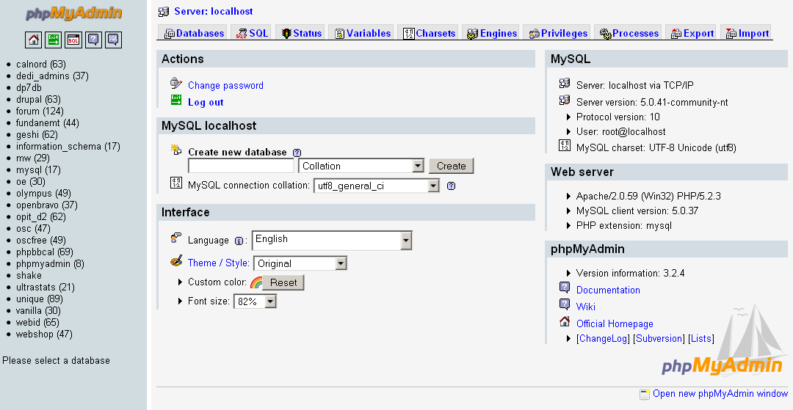

3. Amaliy baza (tayyor database)
Database: db_universitet
3 ta jadval:
fakultetlar
- id (PK)
- nomi
talabalar
- id (PK)
- ism
- kurs
- fakultet_id (FK)
fanlar
- id (PK)
- fan_nomi
- kredit
- talaba_id (FK)

4. Oddiy SELECT so‘rovi
SELECT * FROM talabalar;

5. JOIN so‘rovi
SELECT
talabalar.ism,
talabalar.kurs,
fakultetlar.nomi AS fakultet,
fanlar.fan_nomi
FROM talabalar
INNER JOIN fakultetlar ON talabalar.fakultet_id = fakultetlar.id
INNER JOIN fanlar ON talabalar.id = fanlar.talaba_id;

6. PHP orqali ulanish usullari
6.1 MySQLi – Procedural usul
<?php
$conn = mysqli_connect("localhost", "root", "", "db_universitet");
if (!$conn) {
die("Ulanish xatoligi: " . mysqli_connect_error());
}
$sql = "SELECT * FROM talabalar";
$result = mysqli_query($conn, $sql);
while ($row = mysqli_fetch_assoc($result)) {
echo $row['ism'] . " - " . $row['kurs'] . "<br>";
}
mysqli_close($conn);
?>
Xususiyatlari:
- Oddiy
- Faqat MySQL bilan ishlaydi
- Xavfsizlik PDO ga qaraganda pastroq
6.2 MySQLi – Object Oriented usul
<?php
$conn = new mysqli("localhost", "root", "", "db_universitet");
if ($conn->connect_error) {
die("Xatolik: " . $conn->connect_error);
}
$sql = "SELECT * FROM talabalar";
$result = $conn->query($sql);
while ($row = $result->fetch_assoc()) {
echo $row['ism'] . "<br>";
}
$conn->close();
?>
Xususiyatlari:
- OOP yondashuv
- Professionalroq
- Katta loyihalar uchun qulay
6.3 PDO usuli (Tavsiya etiladi)
<?php
try {
$conn = new PDO("mysql:host=localhost;dbname=db_universitet", "root", "");
$conn->setAttribute(PDO::ATTR_ERRMODE, PDO::ERRMODE_EXCEPTION);
$sql = "SELECT * FROM talabalar";
$stmt = $conn->query($sql);
while ($row = $stmt->fetch(PDO::FETCH_ASSOC)) {
echo $row['ism'] . "<br>";
}
} catch(PDOException $e) {
echo "Xatolik: " . $e->getMessage();
}
?>
Xususiyatlari:
- Turli DB lar bilan ishlaydi (MySQL, PostgreSQL, Oracle)
- Eng xavfsiz
- Prepared Statement kuchli
- try-catch bilan ishlaydi

7. PDO orqali JOIN misoli
<?php
try {
$conn = new PDO("mysql:host=localhost;dbname=db_universitet", "root", "");
$conn->setAttribute(PDO::ATTR_ERRMODE, PDO::ERRMODE_EXCEPTION);
$sql = "SELECT
talabalar.ism,
talabalar.kurs,
fakultetlar.nomi AS fakultet,
fanlar.fan_nomi
FROM talabalar
INNER JOIN fakultetlar
ON talabalar.fakultet_id = fakultetlar.id
INNER JOIN fanlar
ON talabalar.id = fanlar.talaba_id";
$stmt = $conn->query($sql);
echo "<table border='1'>";
echo "<tr><th>Ism</th><th>Kurs</th><th>Fakultet</th><th>Fan</th></tr>";
while ($row = $stmt->fetch(PDO::FETCH_ASSOC)) {
echo "<tr>
<td>{$row['ism']}</td>
<td>{$row['kurs']}</td>
<td>{$row['fakultet']}</td>
<td>{$row['fan_nomi']}</td>
</tr>";
}
echo "</table>";
} catch(PDOException $e) {
echo "Xatolik: " . $e->getMessage();
}
?>

8. Usullarni taqqoslash
Xususiyat | MySQLi Procedural | MySQLi OOP | PDO
DB turi | Faqat MySQL | Faqat MySQL | Ko‘p DB
Xavfsizlik | O‘rtacha | Yaxshi | Eng yaxshi
try-catch | Yo‘q | Yo‘q | Bor
Prepared | Bor | Bor | Juda kuchli
Professional | O‘rtacha | Yaxshi | Eng yaxshi

9. Natija
Laboratoriya ishida:
- Tayyor MySQL bazaga ulanish amalga oshirildi
- SELECT so‘rovi bajarildi
- INNER JOIN ishlatildi
- 3 xil PHP usuli taqqoslandi
- PDO eng tavsiya etiladigan usul ekanligi ko‘rsatildi
Topshiriqlar:

12-IT kompaniya tizimi
Database: db_itcompany

Jadvallar:
xodimlar
- id
- ism
- lavozim
loyihalar
- id
- nomi
- boshlanish_sana
vazifalar
- id
- loyiha_id (FK)
- xodim_id (FK)
- vazifa_nomi

Bog‘lanish:
- vazifalar.loyiha_id → loyihalar.id
- vazifalar.xodim_id → xodimlar.id

JOIN vazifa:
Xodim + Loyiha + Vazifa nomi chiqarish.

Talaba nima qiladi?
- PDO ulanish
- 3 jadvalni vazifalar orqali bog‘laydi
- JOIN query yozadi
- Jadval ko‘rinishida chiqaradi
Amaliy qismi:
PHP:
<?php
$host = "localhost";
$dbname = "db_itcompany";
$username = "root";
$password = "";

$pdo = new PDO("mysql:host=$host;dbname=$dbname;charset=utf8mb4", $username, $password);
$pdo->setAttribute(PDO::ATTR_ERRMODE, PDO::ERRMODE_EXCEPTION);

# CRUD
if (isset($_POST['add'])) {
$pdo->prepare("INSERT INTO xodimlar (ism, lavozim) VALUES (?, ?)")
->execute([$_POST['ism'], $_POST['lavozim']]);
}

if (isset($_GET['delete'])) {
$pdo->prepare("DELETE FROM xodimlar WHERE id=?")
->execute([$_GET['delete']]);
}

if (isset($_POST['update'])) {
$pdo->prepare("UPDATE xodimlar SET ism=?, lavozim=? WHERE id=?")
->execute([$_POST['ism'], $_POST['lavozim'], $_POST['id']]);
}

# SEARCH + JOIN
$search = $_GET['search'] ?? '';

$stmt = $pdo->prepare("
SELECT x.ism, l.nomi, v.vazifa_nomi
FROM vazifalar v
JOIN xodimlar x ON v.xodim_id = x.id
JOIN loyihalar l ON v.loyiha_id = l.id
WHERE l.nomi LIKE :search
");
$stmt->execute([':search' => "%$search%"]);
$data = $stmt->fetchAll(PDO::FETCH_ASSOC);

$xodimlar = $pdo->query("SELECT * FROM xodimlar")->fetchAll(PDO::FETCH_ASSOC);

$editData = null;
if (isset($_GET['edit'])) {
$stmt = $pdo->prepare("SELECT * FROM xodimlar WHERE id=?");
$stmt->execute([$_GET['edit']]);
$editData = $stmt->fetch(PDO::FETCH_ASSOC);
}
?>

HTML:

<!DOCTYPE html>
<html>
<head>
<title>IT Company System</title>
<link rel="stylesheet" href="style.css">
</head>
<body>

<div class="container">

<h2>Xodim qo‘shish / tahrirlash</h2>

<form method="POST">
<input type="hidden" name="id" value="<?= $editData['id'] ?? '' ?>">
<input type="text" name="ism" placeholder="Ism" value="<?= $editData['ism'] ?? '' ?>" required>
<input type="text" name="lavozim" placeholder="Lavozim" value="<?= $editData['lavozim'] ?? '' ?>" required>

<?php if ($editData): ?>
<button name="update">Yangilash</button>
<?php else: ?>
<button name="add">Qo‘shish</button>
<?php endif; ?>
</form>

<h2>Xodimlar</h2>

<table>
<tr>
<th>ID</th>
<th>Ism</th>
<th>Lavozim</th>
<th>Action</th>
</tr>

<?php foreach ($xodimlar as $x): ?>
<tr>
<td><?= $x['id'] ?></td>
<td><?= htmlspecialchars($x['ism']) ?></td>
<td><?= htmlspecialchars($x['lavozim']) ?></td>
<td>
<a href="?edit=<?= $x['id'] ?>">Edit</a>
<a href="?delete=<?= $x['id'] ?>" onclick="return confirm('O‘chirilsinmi?')">Delete</a>
</td>
</tr>
<?php endforeach; ?>
</table>

<h2>Qidiruv</h2>

<form method="GET">
<input type="text" name="search" placeholder="Loyiha nomi">
<button>Qidirish</button>
</form>

<h2>JOIN natija</h2>

<table>
<tr>
<th>Xodim</th>
<th>Loyiha</th>
<th>Vazifa</th>
</tr>

<?php foreach ($data as $row): ?>
<tr>
<td><?= htmlspecialchars($row['ism']) ?></td>
<td><?= htmlspecialchars($row['nomi']) ?></td>
<td><?= htmlspecialchars($row['vazifa_nomi']) ?></td>
</tr>
<?php endforeach; ?>
</table>

</div>

</body>
</html>
CSS:

body {
font-family: Arial, sans-serif;
background: #f4f6f9;
margin: 0;
padding: 20px;
}

h2 {
color: #333;
}

form {
margin-bottom: 20px;
}

input {
padding: 10px;
margin: 5px;
border: 1px solid #ccc;
border-radius: 5px;
}

button {
padding: 10px 15px;
border: none;
background: #007bff;
color: white;
border-radius: 5px;
cursor: pointer;
}

button:hover {
background: #0056b3;
}

table {
width: 100%;
border-collapse: collapse;
background: white;
margin-top: 10px;
}

table th {
background: #007bff;
color: white;
padding: 10px;
}

table td {
padding: 10px;
border-bottom: 1px solid #ddd;
}

tr:hover {
background: #f1f1f1;
}

a {
text-decoration: none;
margin-right: 10px;
color: #007bff;
}

a:hover {
text-decoration: underline;
}

.container {
max-width: 900px;
margin: auto;
background: white;
padding: 20px;
border-radius: 10px;
box-shadow: 0 0 10px rgba(0,0,0,0.1);
}

MySQL:

CREATE DATABASE db_itcompany;
USE db_itcompany;

-- xodimlar jadvali
CREATE TABLE xodimlar (
id INT AUTO_INCREMENT PRIMARY KEY,
ism VARCHAR(100),
lavozim VARCHAR(100)
);

-- loyihalar jadvali
CREATE TABLE loyihalar (
id INT AUTO_INCREMENT PRIMARY KEY,
nomi VARCHAR(100),
boshlanish_sana DATE
);

-- vazifalar jadvali
CREATE TABLE vazifalar (
id INT AUTO_INCREMENT PRIMARY KEY,
loyiha_id INT,
xodim_id INT,
vazifa_nomi VARCHAR(255),
FOREIGN KEY (loyiha_id) REFERENCES loyihalar(id),
FOREIGN KEY (xodim_id) REFERENCES xodimlar(id)
);

Jadvallar:

-- xodimlar
INSERT INTO xodimlar (ism, lavozim) VALUES
('Ali', 'Dasturchi'),
('Vali', 'Dizayner'),
('Sami', 'Backend Developer');

-- loyihalar
INSERT INTO loyihalar (nomi, boshlanish_sana) VALUES
('CRM tizim', '2025-01-10'),
('E-commerce sayt', '2025-02-15');

-- vazifalar
INSERT INTO vazifalar (loyiha_id, xodim_id, vazifa_nomi) VALUES
(1, 1, 'Login modul yozish'),
(1, 2, 'UI dizayn qilish'),
(2, 3, 'API yaratish'),
(2, 1, 'To‘lov integratsiyasi');

Sayt ko’rinishi:
